## Setup

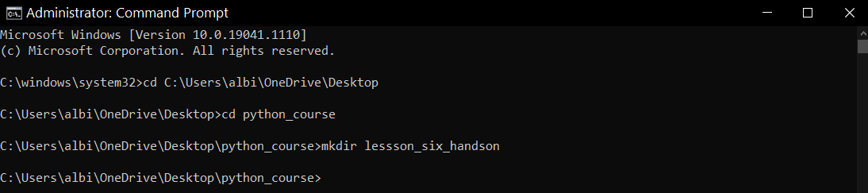

## Part 1

1. Create a class named Stadium
2. Use the init method to include the following three properties:

* name
* city_state
* capacity

Hint! What is the property that is included in every method? Don't forget that one!

1. Initialize each property/attribute within the init method
2. Include a docString for the class and method
3. Create another method within the Stadium class named describe_stadium
4. The describe_stadium method should utilize each method from the Stadium class which will then print a description of the arena (see step 10 for an example of a description).
5. Create a new instance of the Stadium class named stadium1.
6. The stadium1 instance should provide values for each of the three properties of the Stadium class
7. Finally, stadium1 should call the describe_stadium method.
8. The output should be similar to the following:

The Mercedes Benz Arena is located in Atlanta, GA and holds 70,000 fans.

Python commands:

class Stadium:

"""This class models a stadium."""

def __init__(self, name, city_state, capacity):

"""This is the initializer of the 'Stadium' class."""

self.name = name

self.city_state = city_state

self.capacity = capacity

def describe_stadium(self):

"""This method describes the arena."""

print("The", self.name, "is located in", self.city_state, "and holds", self.capacity, "fans.")

Stadium1 = Stadium("Mercedes Benz Arena", "Atlanta, GA", "70,000")

Stadium1.describe_stadium()

Results:

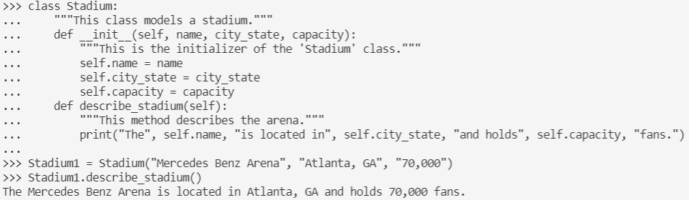

## Part 2

1. Add two more methods to the Stadium class:

* sport_played - This method should accept one argument that specifies the sport that is played
* seats_available - This method should accept one argument that specifies how many seats are available

1. Each of the above method should print out a sentence using the argument provided (see step 4 for output)
2. Using the stadium1 instance, call each of the new methods, providing the relevant arguments. As an example, if the following code to use the class were added:
3. After running this program in your terminal, the output should be similar to the following:

The Mercedes Benz Arena is in Atlanta, GA and holds 70000 fans.

The following sport is mainly played in this stadium: Football

There are 15000 seats still available for tonight's game.

Python commands:

class Stadium:

"""This class models a stadium."""

def __init__(self, name, city_state, capacity, sports, seats):

"""This is the initializer of the 'Stadium' class."""

self.name = name

self.city_state = city_state

self.capacity = capacity

self.sports = sports

self.seats = seats

def describe_stadium(self):

"""This method describes the arena."""

print("The", self.name, "is located in", self.city_state, "and holds", self.capacity, "fans.")

def sport_played(self):

"""This method specifies the sport that is played."""

print("The following sport is mainly played in this stadium:", self.sports)

def seats_available(self):

"""This method specifies the number of seats available."""

print("There are", self.seats, "seats available for tonight's game.")

Stadium1 = Stadium("Mercedes Benz Arena", "Atlanta, GA", "70,000", "Football", "1500")

Stadium1.describe_stadium()

Stadium1.sport_played()

Stadium1.seats_available()

Results:

